EEC284 001 Embedded Computing System

Heart Rate Detection and Sensitivity and Noise Analysis Report

Qingwei Dai & Zhousheng Chen

Materials in Use:

-CC3200 LaunchPad(CC3200Launchpad, Texas Instruments)

-External ADC (MCP3001, Microchip Technology Inc.)

-IR LED (IR908-7C-F, Everlight)-Photodetectorw/ integrated trans

-impedance amplifier (OPT101, Texas Instruments)

-1000Ω Resistors

The circuit is designed based on the datasheets of MCP3001(A/D Converter, ADC), OPT101(Amplifier), IR908(Infrared LED) and CC3200 LaunchPad(Microcontroller).

The main function of this circuit is to detect the heartbeat rate when placing our finger on the OPT101 chip in a dark environment, using Sidelooker Infrared LED to provide the light source. As the Infrared LED send out the light and reflected or refracted by finger, the ADC gets the environment signal and transfer it to a series of digital signal, and send it to the amplifier, the amplifier sends the signal to the microcontroller to analysis the signal and output a cleaned data with our heart rate.

**What we have**

**Hardware Part**

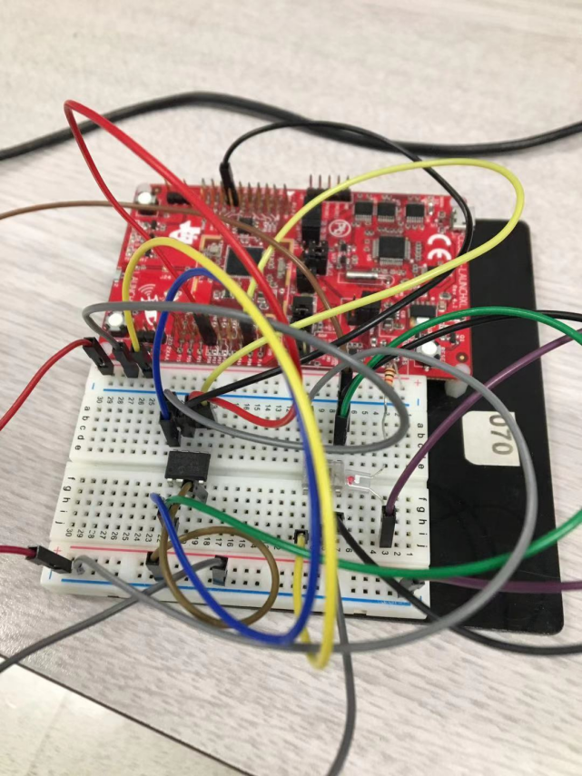

The amplifier output is connected to SPI_CS on the CC3200 launchpad, all VDD, VREF and Vs are connected to 5V power supply, Vss and common are connected to the ground. The output of ADC is connected to the IN+ of the amplifier. Infrared LED and a 1000Ω Resister in series in an isolated circuit right next to OPT101.

The circuit we have connected can read the series of signals of our heart beats. The images of oscilloscope are shown below. The signal we got in the oscilloscope was very weak, as we can see, we scaled the voltage to 10 mV, but still the heart rate signal was not clear, and the signal could be easily interrupted by even the slightly move of finger. Sometimes we could get a clearer signal when the oscilloscope condition got better.

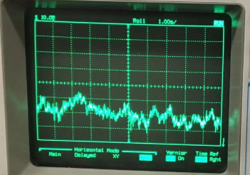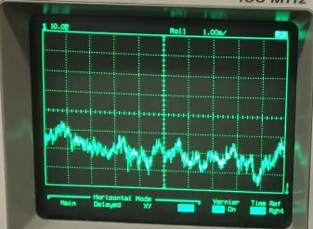

**Software Part**

We can get a series of signals form the microcontroller, but mainly are noises. Most of the time the amplifier sent a series of 0 or 1023 to the microcontroller. When we used clothes to cover the circuit board, the microcontroller got 0; when the cover was moved away, the microcontroller got 1023 instead. After we add buffer, a series of number was got by the microcontroller. The plots are shown below.

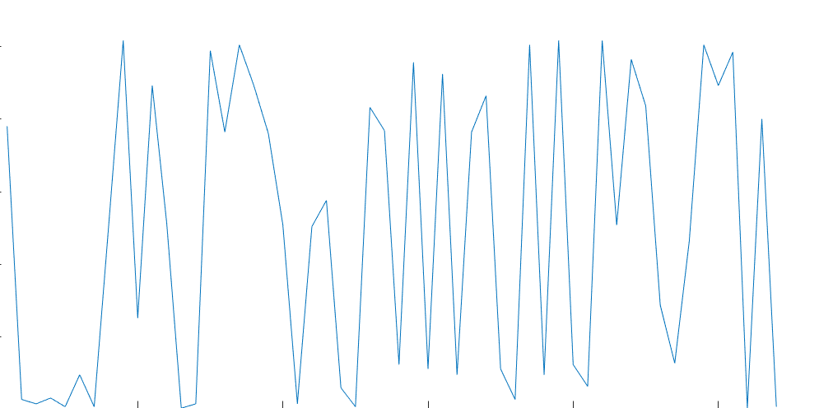

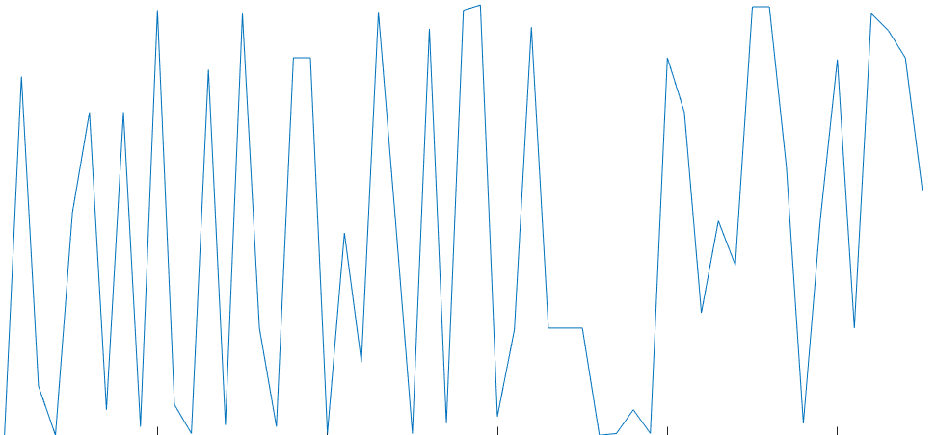

**Noise Evaluation**

As we can see from the oscilloscope, even though we can see the heartbeat, there are a lot of noises. The noises showed on the oscilloscope are mainly from environment, especially form the day light and fluorescent lamp. The noises that microcontroller get are mainly form the noises that are sent from the ADC and amplified by the amplifier. If the signals and noises that ADC detected are *Sig1 + N1*, then the signal and noises sent out from the amplifier should be *g(Sig1+N1)+N2*. So, it is important to clear the noise before it is sent to the amplifier.

Noise Floor dBm= 10log(K * T0 *1000) + NF + 10logBW

= 10log(1.38 * 10-23 * 291.15 * 1000) + 61 + 10log(14000)

= -71.5 dBm

After the microcontroller gets the signal, the signal should also be cleaned by the algorithm, so that the output data should be clearer and more meaningful.

**Improvement**

The improvement we are going to make before the next milestone are listed below:

1. Add a low-pass filter before the heartbeat signals are sent to the amplifier;
2. Add another amplifier to enhance the output signal, so we can see a clearer signal in both oscilloscope and microcontroller;
3. Add high-pass filter if necessary;
4. Design the algorithm to detect the heartbeat wave, either peak-to-peak or calculate the lower slope;
5. Add filter algorithm like Finite Impulse Response Filter or Fast Fourier Transform Filter to clear the signal.